

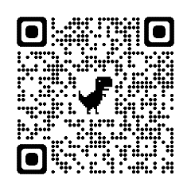

Adrian Moore
Senior Case Manager

Adrian has a caring and empathetic approach to working with his clients and their families. He is thorough and methodical in his approach, with a keen eye for the small details that ultimately make a big difference to the lives of those he works with.
Adrian works as part of the adult team with a varied case load including clients with brain injury, spinal injury and complex disabilities.
Adrian is experienced in undertaking initial needs assessments as well as the preparation of costed case management proposals and rehabilitation code reports. He is responsible for the co-ordination, monitoring and supervision of support and rehabilitation packages for clients.

Specialisms
- Managing support packages
- Coordinating multi-disciplinary teams
- Registered general nurse (adults)

Professional Qualifications
- Registered General Nurse Adults (Diploma)
- NU3640 Enhancing Care for People with Neuromedical Disorders
- Preparation for Mentorship
- Medical Nursing Module
- D32/33 NVQ Assessor

Memberships
British Association of Brain Injury Case Managers (BABICM) – Advanced Member
Nursing and Midwifery Council (NMC)
Royal College of Nursing (RCN)

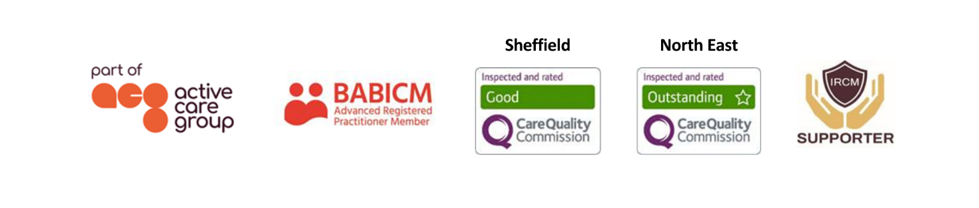

Contact

Visit our website

Call 0114 229 0100

Email

Experience

Adrian has worked in the field of rehabilitation within the NHS since qualifying as a registered nurse in 1999. He began his career working within orthopaedics and general rehabilitation and then went on to work within vascular rehabilitation, caring for individuals with lower limb amputations.

In 2004, Adrian was appointed as charge nurse on the Intermediate Neurological Rehabilitation Unit at Central Manchester Hospitals. The unit provided care and rehabilitation for adults with complex needs following acquired/traumatic brain injuries, spinal injuries and various other neurological issues. Adrian worked as part of a large multidisciplinary team supporting the individual, their families and carers.

Adrian undertook various courses and training, gaining experience and specialist knowledge which enabled him to enhance and develop his skills to manage complex individuals and the challenging behaviours associated with individuals who have sustained a brain injury.

Adrian managed and supported a large nursing team through periods of significant change. Throughout these periods, he ensured standards and high-quality care were maintained at all times. Adrian has been involved in the recruitment of nursing and support worker staff and has been actively involved with the UK Rehabilitation Outcomes Collaborative (UKROC).

Adrian also has personal experience supporting a family member with a neurological condition, acting as their advocate at times; this experience gave him the understanding of the pressures family members have to contend with when caring for complex individuals. He joined JSP Ltd to utilise his extensive skills and knowledge as a case manager.

