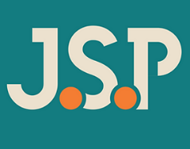
Becky Murray
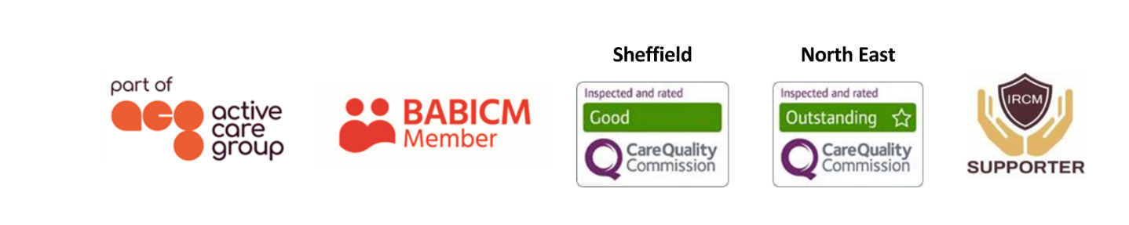
Case Manager
As an experienced case manager, Becky holds a varied caseload of adult clients with brain injury and other complex disabilities.  Responsible for needs assessments, she coordinates bespoke support for clients - both pre and post settlement. This involves the recruitment, induction, supervision, and management of support staff; monitoring of rehabilitation packages; working with the client’s family as well as the production of witness evidence for use in litigation.  Specialisms  - Brain injury  - Working with complex neurological conditions  - Community brain injury rehabilitation  - Cognitive rehabilitation  - Adult care  - Pre-trial packages  - 24/7 support packages  Professional Qualifications  - BSc (Hons) Occupational Therapy  Memberships  British Association of Brain Injury Case Managers (BABICM)  Health and Care Professions Council (HCPC) |  |  |   Contact  Visit our website  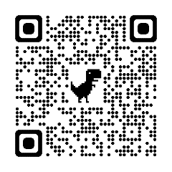  Call 0114 229 0100  Email
Experience

Becky’s career as an occupational therapist covered a broad range of services and client groups; her posts included various positions in hospitals, community teams and social services.

As a result of her career experiences Becky developed a specialist interest in neurology and neurological rehabilitation and then tailored her job opportunities and training to reflect this. Becky has worked with clients who have had a variety of neurological conditions including clients with traumatic brain injuries. Her roles included carrying out detailed assessments of need, devising treatment programmes, setting and reviewing of client centred goals and complex discharge planning. A key role undertaken by Becky was to develop close links with social services and other professionals and agencies to ensure that community services were both holistic and specific to her clients’ needs.

Becky is committed to delivering a high level of service to clients and their families, ensuring a holistic approach to care as well as establishing a great rapport with those she works with.

