
Caroline Jepson
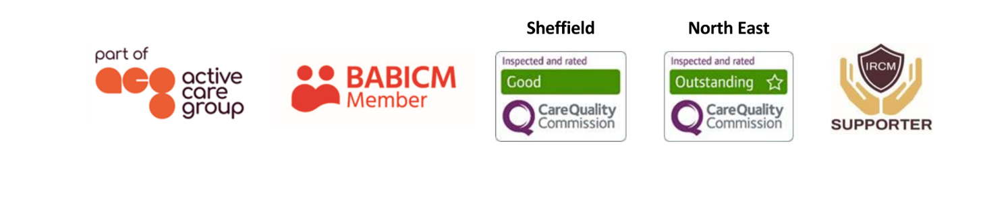
Case Manager
As well as being an experienced case manager, Caroline possesses detailed knowledge of the medico-legal process as a consequence of her time spent as a lawyer.  She has a wealth of experience in supporting clients who have complex physical disabilities and cognitive needs as a result of having had a traumatic injury, as well as overseeing support packages with large teams.  Caroline is proficient in assessment and report writing and has worked extensively with clients and their families who have pursued personal injury cases through the litigation process.  Caroline is adept in assessing needs, supporting individuals and their families, and negotiating with a wide range of agencies to ensure that appropriate levels of care and support are provided.  Specialisms  - Brain injury  - Spinal injury  - Cerebral Palsy  - Complex disabilities  - 24/7 support packages  - Medico-legal process  - Adult care  Professional Qualifications  - CILEx Lawyer (FCILEx)  Memberships  British Association of Brain Injury Case Managers (BABICM) |  |  | 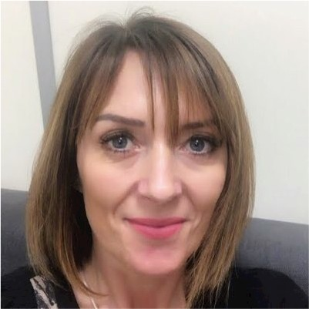  Contact  Visit our website    Call 0114 229 0100  Email

Experience

Caroline began her legal career in a small firm of solicitors in Sheffield covering criminal law before moving to a specialist personal injury department in a national legal firm in 1997 where she initially conducted prison law and public law cases. Caroline found her niche in the field of claimant personal injury and specialised in representing clients who had sustained life changing injuries. She has significant experience in conducting brain and spinal injury claims as well as helping clients with complex health needs access rehabilitation.

When litigating serious injury cases where funds for a case manager were not available, Caroline would often act as ‘case manager’ for clients by accessing statutory services, assessing the needs of clients and their families and identifying relevant and cost effective resources which were available in order to obtain maximum benefit for the client and the family.

Having worked alongside independent case managers for many years, Caroline is aware of how having an experienced case manager can make life so much easier. Knowing that clients are in good hands, getting the rehabilitation they need and the care regime properly managed is crucial to clients and their families.

Caroline has a friendly, calm and collected manner as well as being efficient and highly organised. She enjoys solving problems and exploring alternative solutions to challenges.

