
Denise Slack
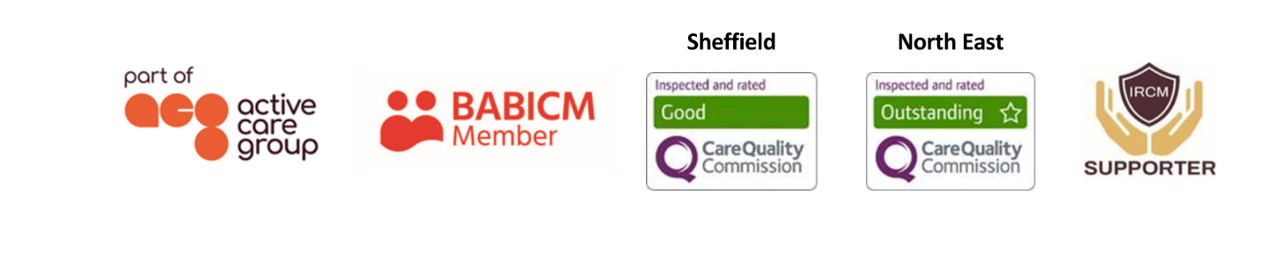
Case Manager
Denise is a sensitive and empathetic person who likes to bring out the best in people. Her occupational therapy experience has allowed her the opportunity to confidently lead on rehabilitation cases, ensuring that her clients have clear personalised goals and evidenced outcome measures to ensure progress. Denise’s particular interest is working with clients with cognitive, emotional and behavioural impairments which impact of their functional performance in all aspects of everyday life and employment.  Specialisms  - Brain injury  - Cognitive rehabilitation  - Vocational rehabilitation  - Outcome measures  - Design of bespoke goal-orientated programmes  Professional Qualifications  - BSc (Hons) Occupational Therapy  Memberships  Health Care Professions Council (HCPC)  British Association of Occupational Therapists (BAOT)  Royal College of Occupational Therapists (RCOT) |  |  | 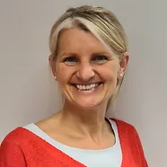  Contact  Visit our website  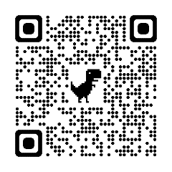  Call 0114 229 0100  Email
Experience
Denise qualified as an occupational therapist in 1996 and began working at Sunderland Hospital as a rotational basic grade OT in the areas of orthopaedics, elderly rehabilitation and mental health.
Denise then moved to Sheffield in 1998 for a senior rotational position at Sheffield Teaching Hospitals, where she gained experience on the neurosurgical and neuromedical wards in the Royal Hallamshire Hospital. Following this, she worked in an interdisciplinary community brain injury team. This experience sparked Denise’s interest in working in neurology and, in particular, the field of brain injury. Not only did she gain experience in working with clients and families in the early management of their neurological condition but also in their long-term management.
Denise then moved to Barnsley PCT where she developed the role of the outreach occupational therapy service with a special interest in vocational rehabilitation. This role involved Denise working as part of an interdisciplinary team providing cognitive, functional and vocational rehabilitation assessments and interventions to clients with a neurological diagnosis. As part of this role she also managed complex neurological cases, mainly focusing on behavioural and cognitive difficulties, carrying out complex assessments as part of the team and identifying future rehabilitation needs.
Denise has experience of working alongside the private sector as an NHS practitioner and is aware of the value of having excellent communication skills in order to facilitate this process, as well as the value of carefully considering cost effective interventions. Denise has excellent verbal and written communication skills, a strong work ethic and values the importance of listening, motivating and inspiring others. She is competent at report writing and does so in a sensitive and accurate manner.
Denise has continued to maintain her professional standards throughout her career and has done this through furthering her clinical knowledge, liaising with other professionals, continuously reflecting on practice and sharing this with others.
During 2006 and 2007 Denise was a visiting lecturer at York St John University, teaching neurological rehabilitation - specifically brain injuries. This post allowed her to gain further insight into the relevance and importance of evidence based practice within this setting.
She completed a Masters module at Hallam University in 2010 exploring the subject of ‘Insight and Awareness following Brain Injury’. In 2011, she undertook further studies at Sheffield Teaching Hospitals exploring ‘The Value of Investing in a Vocational Rehabilitation Service’.
Commitment to brain injury is demonstrated by Denise’s involvement as a committee member of the South Yorkshire Acquired Brain Injury Forum.

