
Fen Parry
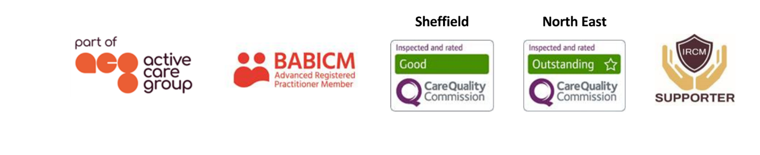
Regional Manager & Case Manager
Fen is a registered social worker with over 35 years’ experience of working in both community and hospital settings with a range of client groups. She has experience of working with clients with learning disabilities, physical disabilities, and mental health problems; working in brain injury specific services since 1997.  Working with both adults and children, Fen’s cases range from 24-hour care packages to individuals receiving minimal support. She is experienced in preparing care expert reports and is Bond Solon trained.  Specialisms  - Brain injury  - Spinal injury  - Cerebral Palsy  - Mental Health  - Complex disabilities  - Capacity and guardianship  - Medico-legal process  - Paediatric and Adult care  - Pre-trial packages  - 24/7 support packages  Professional Qualifications  - Certificate of Qualification in Social Work  - Diploma in Social Work  - Post qualifying awards in practice teaching and as a mental health officer  Memberships  British Association of Brain Injury Case Managers (BABICM) – Advanced Member  Scottish Social Services Council (SSSC) |  |  | 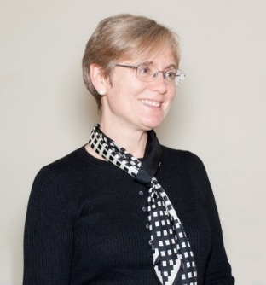  Contact  Visit our website  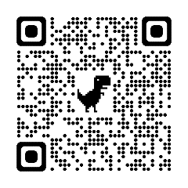  Call 0114 229 0100  Email

Experience

Fen undertook her professional training in social work in Aberdeen. Post qualifying, she worked for City of Edinburgh Council’s social work department as a specialist worker in learning disability. She trained as a mental health officer in 1993 and qualified as a practice teacher in 1996.

In 1997, Fen took up post as senior social worker at the Scottish Neurobehavioural Rehabilitation Service (SNBRS), part of a multidisciplinary team providing a service to individuals with significant psychological or behavioural consequences of acquired brain injury. Her responsibilities included provision of support to patients and carers; preparation of reports; assessment and case management; planning, organising and sourcing funding for packages of care; identifying appropriate discharge resources and co-ordinating discharge planning arrangements; liaison with local authorities, health boards, statutory, voluntary and private organisations; and supervision of staff. She gained considerable experience of multidisciplinary working and a comprehensive understanding of the roles of other professionals working within the field of acquired brain injury.

In 2007 Fen joined JSP Ltd, providing case management services to clients living in both Scotland and the North East of England.

Fen spent 7 years as vice chair of Headway’s Scotland development committee and served a further 4 years as a co-opted member of the committee. For 10 years, she was the Scotland co-ordinator of the Brain Injury Social Work Group and organised 2 conferences each year on topics of interest to workers in the field. She has undertaken the role of committee member for BABICM’s Scottish subgroup and has been involved in organising educational events as part of this role. Her voluntary work experience includes five years as a volunteer with Nucleus, an organisation providing support to the families of children with special needs, and more recently helping at a group for children affected by familial brain injury.

In April 2017, Fen was selected by the Child Brain Injury Trust to be their sole representative to run the London Marathon and she raised over £5000 in the process.

Fen enjoys multidisciplinary working and the challenges it presents. She values being able to work closely with clients, families and carers, supporting them through changes and rehabilitation.

