

Helen Graham
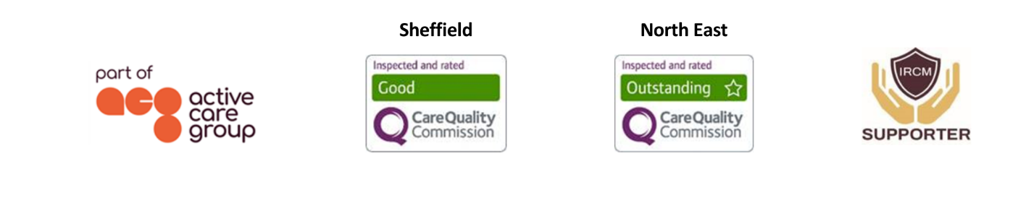
Case Manager and Senior OT
As an experienced occupational therapist and case manager, Helen is skilled in assessing her clients’ needs, the impact these have on an individual's function, and considering how these change over time. Helen is a strong advocate for inter-disciplinary working, striving to establish excellent relationships with other professionals, clients and their families.  She coordinates bespoke support and has a special interest in working with post-settlement cases. Her role involves the recruitment, induction, supervision and management of support staff; the monitoring of rehabilitation packages as well as working closely with the client’s family, ensuring the client is at the heart of everything she does.  Specialisms  - Brain injury  - Spinal injury  - Moving and Handling training lead  - Equipment and adaptations  - Design of bespoke goal-oriented programmes  - Specialist housing solutions  - Falls prevention and solutions  - Paediatric and Adult care  - 24/7 support packages  Professional Qualifications  - BSc (Hons) Occupational Therapy  - Moving and Handling Train the Trainer  Memberships  Royal College of Occupational Therapy (RCOT)  Health and Care Professions Council (HCPC)  National Back Exchange Member (NBE) |  |  |   Contact  Visit our website    Call 0114 229 0100  Email

Experience

After qualifying as an occupational therapist in 2001, Helen was employed by the Newcastle-upon-Tyne Foundation Trust and completed a rotational post in elective orthopaedics, medicine and surgery. This role involved acute assessment, initial goal setting, rehabilitation and the provision of adaptive equipment to maximise independence following planned and emergency surgery.

Progressing to a senior II Helen continued her career within burns and plastics, critical care, amputees, stroke assessment, cardiac rehabilitation and care of the elderly. This consisted of a varying age group with complex needs, requiring thorough assessment, utilising a range of outcome measures to allow patients to reach their optimum level of function. This role enabled Helen to undertake additional study at master’s level within stoke rehabilitation, exploring the application of multi-context therapy.

Helen went on to specialise in care of the elderly within an intermediate care unit, working within a close multi-disciplinary framework to provide comprehensive assessment and rehabilitation for complex patients with multiple pathologies.

In January 2009, Helen began working for the Northumbria Healthcare Foundation Trust as a senior occupational therapist for CARE Point. Specialising in admission avoidance and the facilitation of early hospital discharge, she provided: comprehensive assessment of functional capacity with elderly clients within their own homes; prescribed goal-led rehabilitation programmes; equipment and minor adaptations as well as complex moving and handling plans. The interdisciplinary team provided a rapid response to a wide and variable caseload, many of whom had a long term neurological or palliative diagnosis. Helen supported the team with training and continuing personal development opportunities, taking on the role of mock inspector for the Care Quality Commission.

Helen also developed and managed a health and well-being programme, working with the local authority to address falls, which involved gait and balance training, along with educational sessions and personalised home risk assessments, providing specialist adaptations and home adaptations to meet individual needs.

In 2018, Helen joined JSP Ltd as an equipment and adaptations occupational therapist and from there progressed to case manager. Her role includes providing specialist assessment regarding housing solutions, adapting an existing property or identifying long/short term accessible accommodation. She has worked alongside architects to design and guide housing projects encompassing specialist adaptations required for clients and their families. She also provides clinical assessments of clients’ needs for specialist and portable equipment for personal care, mobility, household tasks, education, work, leisure and community activities. In addition to this Helen is our Moving and Handling Training lead supporting the development of our moving and handling service, incorporating specialist assessment of our client’s moving and handling needs, assessment of equipment and the development of bespoke moving and handling plans.

