
Kim Taylor
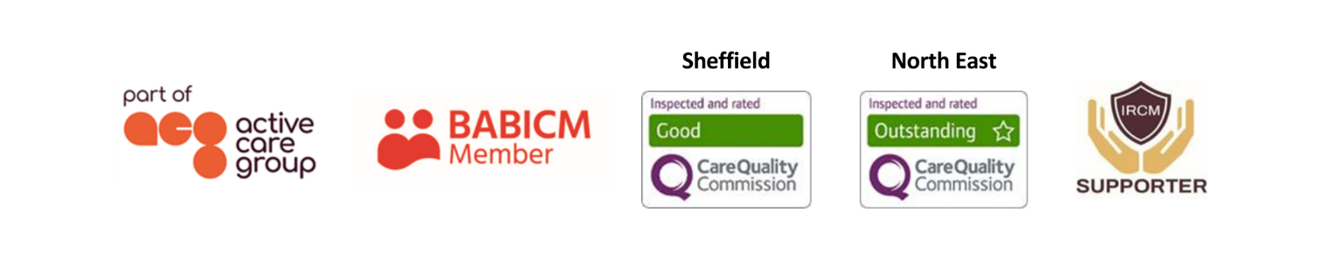
Case Manager
Kim is an empathetic and understanding practitioner who is committed to delivering a high standard of service. She is creative, adaptable and skilled in risk management. She is experienced in client focused service delivery and uses her skills to build a good rapport with the people she supports while maintaining professional relationships.  Kim is a caring, experienced and dedicated case manager who works with adults, children and their families to provide the best possible levels of support to all whether it be respite or 24/7 care that is required. Kim manages support packages, regularly working in tandem with multi-disciplinary teams, via direct recruitment or agency teams, whichever is most appropriate to her clients’ needs.  Specialisms  - Brain injury  - 24/7 support packages  - Training delivery  - Community support  - Residential respite and therapeutic recreation  - Long term neurological conditions  Memberships  British Association of Brain Injury Case Managers (BABICM) |  |  |   Contact  Visit our website  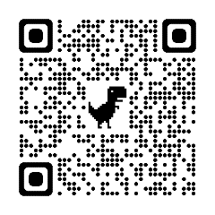  Call 0114 229 0100  Email

Experience
Kim began working with people who have complex support needs from a young age through volunteer work and family friends. During university, and for several years thereafter, she spent the summer working in residential camps for adults with physical and learning disabilities in America. This gave Kim a wide understanding of a range of conditions as well as valuable experience in providing care and adapting activities and environment to the needs of the individual.
After settling in Scotland, Kim joined the Edinburgh Headway Group managing a community-based project for adults with acquired brain injury and their families. This led to a passion for finding creative and personalised ways to support people post injury to maintain a good quality of life.
Kim then moved to Leuchie House as the Guest Engagement Manager. This involved supporting adults with long term physical and neurological conditions during short holiday breaks. During this time Kim managed a team and was responsible for designing and delivering a diverse inhouse activity program which was adaptable to the abilities of each guest as well as co-ordinating all external outings.
Kim has a range of experience setting up and managing care packages. She has proven experience of mentoring team leaders and support workers to build a client centred approach and has built strong working relationships within support teams.
Through her experience working in therapeutic recreation settings, Kim has a special interest in getting people with disabilities to achieve things and take part in activities they don’t expect to be able to do. Alongside work Kim is studying Forensic Mental Health, has experience supporting people within the criminal justice system as well as managing issues related to capacity.

