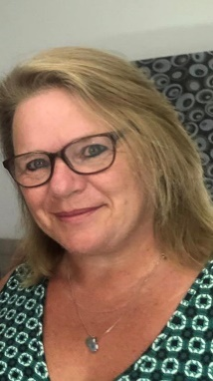

Lucy Pawlak

Case Manager
Lucy has an abundance of experience working with children, young people and their families with a variety of needs including cerebral palsy, visual impairment, learning disabilities and behavioural concerns.  She is adept at co-ordinating packages of care, ensuring that all staff are compliant with their training and providing on-going support to the staff and family to ensure high standards are maintained at all times.  Lucy also has a keen interest in ensuring that children's sensory and play needs are considered, working alongside a variety of therapists to develop these key areas and ensuring that appropriate equipment is available.  Specialisms  - Paediatric care  - Registered nurse  - Complex care  - Sensory and play needs, associated equipment and activities  - Specialist housing solutions  - Multi-disciplinary working  Professional Qualifications  - Registered General Nurse 1986  - Registered Sick Children’s Nurse 1989  - BSc (Hons) Child Health 1998  Memberships  Nursing Midwifery Council (NMC)  Royal College of Nursing (RCN)  British Association of Brain Injury Case Managers (BABICM) |  |  | Contact  Visit our website    Call 0114 229 0100  Email

Experience

Lucy is a dual qualified nurse with many years’ experience working with children, young people and their families.

Prior to case management she had various roles in the NHS, including in hospitals and the community, gaining comprehensive knowledge of assessing and providing care and on-going support to families, children and young people. This included working as a Complex Care Discharge Co-ordinator at two specialist Paediatric Hospitals and managing Continuing Care services both in Buckinghamshire and London.

She is able to adapt and apply her knowledge to ensure that the client’s needs are met within a variety of settings, as well as excelling at networking and building relationships with members of a multi-disciplinary team to ensure that a child or young person has access to all available services to maximise their potential, this includes therapists and supporting families with accessing appropriate education, out of school activities and suitable housing.

