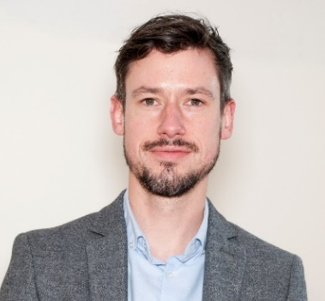

Michael Byrne
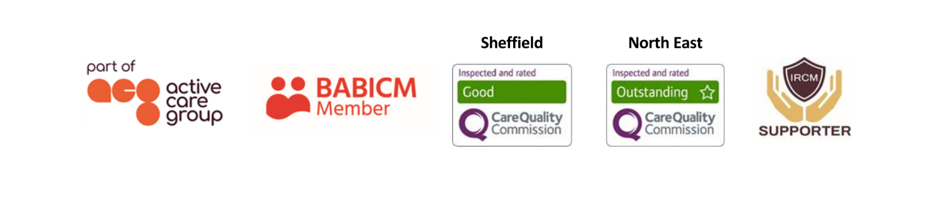
Senior Case Manager
As an experienced case manager, Michael holds a caseload of adults as well as children with brain injury and disabilities. He is committed to ensuring that the client’s wishes are central at all times, regardless of a situation’s complexities.  Responsible for needs assessments, he coordinates support for clients - both pre and post settlement. This involves the recruitment, induction, supervision, and management of support staff; monitoring of rehabilitation packages; working with the client’s family as well as the production of witness evidence for use in litigation.  Specialisms  - Brain injury  - Spinal injury  - Cerebral Palsy  - Complex Disabilities  - Paediatric and Adult care  - Pre-trial packages  - 24/7 support packages  - Autism  - Special Educational Needs  Professional Qualifications  - Qualified Teacher Status  - Postgraduate Certificate in Education  - BA (Hons) Music and Recording  Memberships  British Association of Brain Injury Case Managers (BABICM) |  |  | Contact  Visit our website    Call 0114 229 0100  Email

Experience

Michael has worked in various roles including as a primary school teacher, in addition to as a service manager for an organisation providing opportunities, short breaks and respite services for young adults with ASD, learning disabilities and brain injuries.

In 2005 Michael started his career as a support worker based in the North West, working as part of a team supporting adults with autism spectrum disorder (ASD) and mental health difficulties. In this role, Michael helped clients to develop independent living skills and access the community.

Michael returned home to the North East in 2007 where he began his role as service manager. Michael was responsible for developing person centred plans for service users to ensure they were able to achieve their potential in accessing the community and maintaining an active social life.

From 2011 Michael worked as a class teacher within primary education, delivering to classes of pupils and ensuring planning, preparation, assessment and reporting met the pupils varying learning and social needs.

In 2015, Michael joined JSP as a case manager. Since then he has developed an in depth understanding of brain injury, the need for specialist and tailored support packages, together with expertise in implementing and managing such packages.

Michael is highly motivated to enable individuals achieve their goals. He has strongly developed interpersonal and communication skills, understands that a collaborative approach is key and enjoys finding creative solutions to problems.

