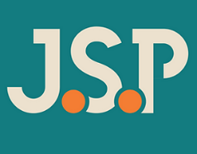
Rachel Blades
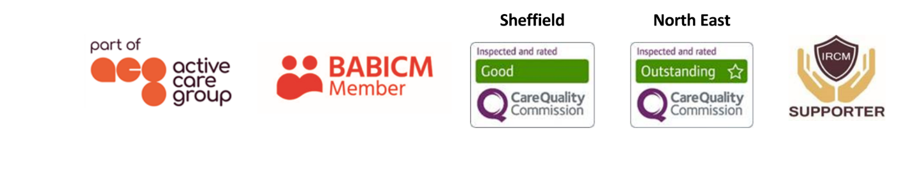
Case Manager
With over 26 years’ experience as a qualified nurse and as an experienced case manager Rachel works with clients – from children through to adults - with spinal injury, brain injury and other complex disabilities.  Responsible for needs assessments, she coordinates support for clients both pre and post settlement. This involves the recruitment, induction, supervision, and management of support staff; monitoring of rehabilitation packages; working with the client’s family as well as the production of witness evidence for use in litigation.  Specialisms  - Traumatic and Acquired Brain Injury  - Spinal Cord Injury and Rehabilitation  - Paediatric and Adult care  - Pre-trial packages  - Psychological support  - Care in the Community  Professional Qualifications  - BMedSci Hons Degree in Nursing Studies  - Diploma in Nursing  - Level 3 Supporting and Teaching in Schools  - Level 2 Understanding Autism  - Understanding Cancer  - Level 2 Counselling Skills  - Dementia Care  Memberships  British Association of Brain Injury Case Managers (BABICM)  Nursing and Midwifery Council (NMC) |  |  | 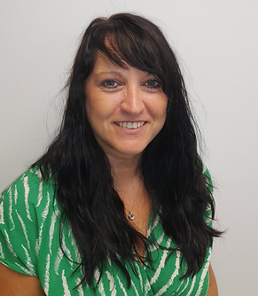  Contact  Visit our website  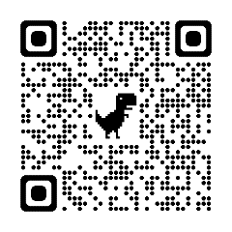  Call 0114 229 0100  Email

Experience
Rachel qualified as a nurse, gaining a Diploma in 1996 before completing a degree in 1999, and is dual registered for adult and child nursing. Rachel’s experience spans health within the NHS and private sector as well as the education and voluntary sectors.

Her first position as a qualified nurse in 1996 was in Neurosurgery at Sheffield where she gained an interest and an in-depth knowledge of brain and spinal injuries as well as other conditions affecting the brain; working with children, young people and adults. Rachel’s next position in 1997 was on the Spinal Injuries Unit in Sheffield where she became trained in all aspects of supporting people with spinal injuries. Here she worked across all three specialities, acute, rehab and continuing care. Whilst working here, Rachel was seconded to do her children’s training and on return, was the children’s lead for the unit which included day surgery, neonatal care and orthopaedics. Rachel also spent time working on the Special Care Baby Unit at Jessops.

From here Rachel spent a few years working in the education sector where she became a voluntary director of a day nursery for children aged 3 months – 5 years, and later embarked upon a post in the learning support department of a high school where she worked with 11–18-year-olds with both behavioural and learning needs including: Asperger’s syndrome, autism, speech and language difficulties, looked after children, dyslexia, Ehrlos- Danlos syndrome and many more. During this post, Rachel ran her own autism groups and small education groups. Within this role she gained both her autism and specialist teaching qualifications.

Rachel gained further specialist skills of caring for people when she took up a post working for the Human Support Group in Rotherham as a reablement worker. This involved supporting and managing the care needs of people in their homes and required working within multi-disciplinary teams.

Rachel’s more recent post on the Spinal Injuries Unit in Sheffield involved working with multi-disciplinary teams to plan care for the adults and young people on the unit. This gave Rachel the opportunity to develop a better understanding of planning discharge for this patient group. Within this time Rachel has gained experience of working with conditions including MS, spinal infections, tumours, COVID complications, mental health, and various injuries. In addition to acute care and rehabilitation, Rachel has a keen interest in the emotional and psychological aspect of supporting people with life changing injuries.

Rachel has also worked for voluntary organisations and was a valued member of the team working for Safe at Last, a charity which supported children who were at risk from running away from home. During this time, Rachel helped develop fundraising, a helpline as well as school workshops and events, giving valuable support to trustees and colleagues. Since 2012, Rachel has also helped develop a children’s theatre group in Rotherham which was originally part of a regeneration project. She worked her way from a parent helper to managing director.

Rachel was drawn to case management as the role would utilise her skills gained through nursing, education and volunteering. As an experienced case manager Rachel has managed a number of pre-trial packages and is committed to ensuring the individuals she works with feel supported, taking a holistic approach to client care.

