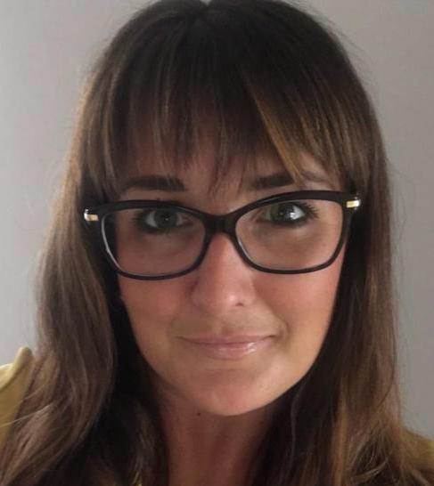
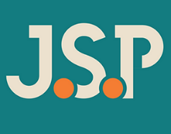
Rachel Eno
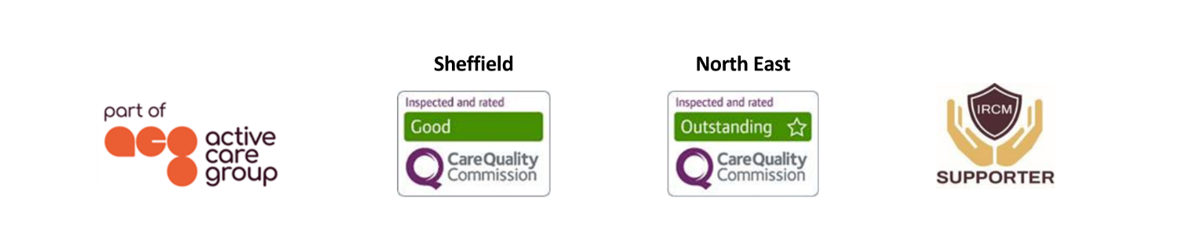
Case Manager
As an experienced case manager, Rachel works with a caseload of adults and older adolescents with complex orthopaedic and musculoskeletal injury, amputations, and psychological trauma.  Responsible for needs assessments, she coordinates bespoke support for clients - both pre and post settlement. This involves the recruitment, induction, supervision and management of support staff; monitoring of rehabilitation packages; working with the client’s family as well as the production of witness evidence for use in litigation.  Specialisms  - Complex Orthopaedic and Musculoskeletal Injury  - Amputee Rehabilitation  - Trauma and Orthopaedics  - Persistent pain  - Psychological trauma  - Return to work  - Adolescent and Adult care  - Pre-trial packages  Professional Qualifications  - Sports Rehabilitation (BSc Hons)  Memberships  Case Management Society UK (CMSUK)  British Association of Sports Rehabilitators and Trainers (BASRaT) |  |  | Contact  Visit our website  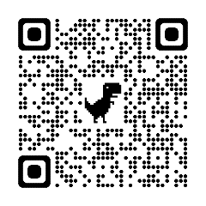  Call 0114 229 0100  Email

Experience
Upon graduation Rachel was employed within a private physiotherapy clinic providing assessment, diagnosis, and treatment of a wide range of orthopaedic and musculoskeletal injuries. Rachel’s patients comprised of members of the public, elite level athletes, local authority employees and others. Through her work with the local authority, Rachel was required to liaise with Health & Safety and HR departments to guide and facilitate successful return to work.

In addition to the patient groups above, Rachel was regularly involved in the treatment and rehabilitation of patients injured through workplace and road traffic accidents. It was through treating these patients and working in conjunction with case managers that Rachel became aware of the role of a Case Manager and developed an interest in pursuing this career pathway.

In May 2011 Rachel moved from private practice to a role as a Rehabilitation Case Manager at HCML. Rachel was able to utilise her detailed knowledge of orthopaedic and musculoskeletal injury gained through her time at the clinic to effectively support clients who had sustained traumatic and often life changing orthopaedic injury, directing their rehabilitation to achieve optimal recovery.

Rachel quickly proved to be adept at identifying the needs of her clients and working collaboratively as part of an MDT, ensuring her clients achieved their goals and rehabilitation potential. An interest in rehabilitation following major limb amputation led to Rachel completing additional training in this field and working with several amputee clients.

Rachel continues to actively seek ongoing training and development opportunities to enhance her knowledge and the service she provides to her clients.

