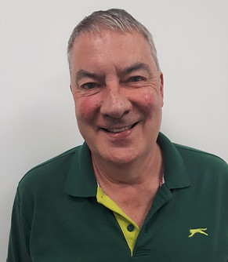

Steve Wright

Case Manager
As an experienced case manager, Steve holds a varied caseload of adult clients with brain injury and other complex disabilities.  Responsible for needs assessments, he coordinates bespoke support for clients and has a special interest in working with post settlement cases. His role involves the recruitment, induction, supervision and management of support staff; the monitoring of rehabilitation packages; and liaising closely with the client’s family to ensure the individuals he works with feel supported and receive the very best care.  Specialisms  - Brain injury  - Cerebral Palsy  - Implementing complex care packages  - Complex disabilities  - Adult care  - 24/7 support packages  Memberships  British Association of Brain Injury Case Managers (BABICM)  Resume of career pathway to date:  Case Manager, JSP Ltd, Sheffield  Therapy Support Services Manager/Outreach Team Co-ordinator at Ash Green Adult Learning Disability Services, Chesterfield  Therap  Technical Instructor, Ash Green Adult Learning Disability Services, Chesterfield |  |  | Contact  Visit our website    Call 0114 229 0100  Email

Experience
After qualifying as a chef in 1975, Steve set out as a budding Gordon Ramsey on a career path that ultimately led to him from working in hotels to managing the catering department at Ash Green Adult Learning Disability Services in Chesterfield. During these years, his life experiences were further enhanced with a stint in the Territorial Army, where he trained as a medic and then as an HGV driver.

A dramatic career change saw Steve transfer over to the occupational therapy department at Ash Green, where he worked as a technical instructor. He worked within a multi-disciplinary team to promote the physical and psychological wellbeing of adults with learning difficulties. One of his crowning moments was when he saw a team of adults through to achieve the Basic Food Hygiene certificate.

Steve was promoted to therapy support services manager and gained 3 years’ experience managing a team of staff providing services under the direction of therapists both on site and in the community, covering the whole of North Derbyshire. He gained a wide range of experience working with adults with learning disabilities and severe challenging behaviour.

Steve has worked as a case manager for JSP Ltd since January 2005. He has experience of setting up 24-hour care packages in the community and supporting people to live as independently as possible. Steve is calm, consistent and reflective. He is thoughtful and measured in his approach, allowing him to get the best outcomes for his clients and their families.

